**DAILY ONLINE ACTIVITIES SUMMARY**

|  |  |  |  |  |  |  |  |  |
| --- | --- | --- | --- | --- | --- | --- | --- | --- |
| **Date:** | **19-05-2020** | | | | | **Name:** | **Shetty Disha Ravindra** | |
| **Sem & Sec** | **VI B sec** | | | | | **USN:** | **4a17cs087** | |
| **Online Test Summary** | | | | | | | | |
| **Subject** | | **Computer Graphics and Visualization** | | | | | | |
| **Max. Marks** | | **60** | | **Score** | | | **55** | |
| **Certification Course Summary** | | | | | | | | |
| **Course** | **Full Stack web Development** | | | | | | | |
| **Certificate Provider** | | | **Udemy** | | **Duration** | | | **19.5hrs** |
| **Coding Challenges** | | | | | | | | |
| **Problem Statement:1]** Write a simple code to identify given linked list is palindrome or not by using stack. First take a Stack. Traverse through each node of the linked list and push each node value to Stack. **2]** A user will input two strings, and we find if one of the strings is a sub sequence of the other. Program prints “yes” if either the first string is a sub sequence of the second string or the second string is a sub sequence of the first string. Assume that, the length of the first string is smaller than or equal to the length of the second string. | | | | | | | | |
| **Status:executed** | | | | | | | | |
| **Uploaded the report in Github** | | | | | **yes** | | | |
| **If yes Repository name** | | | | | **Disha_Shetty** | | | |
| **Uploaded the report in slack** | | | | | **no** | | | |

Online Test Details: (Attach the snapshot and briefly write the report for the same)

Certification Course Details: (Attach the snapshot and briefly write the report for the same)

Coding Challenges Details: (Attach the snapshot and briefly write the report for the same)

Online test

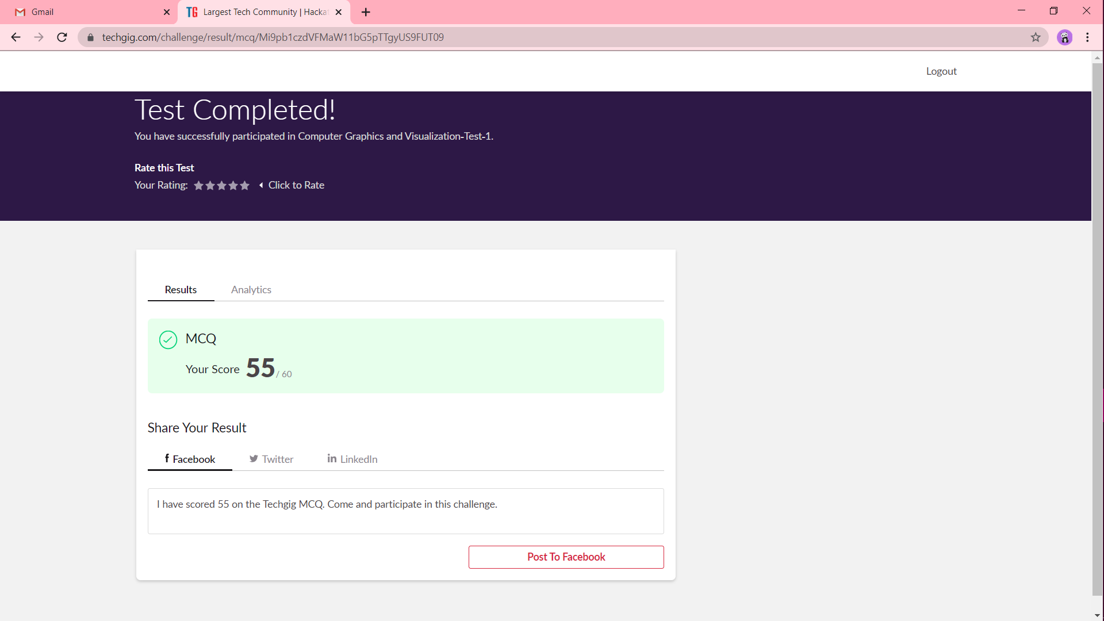

Certification progress

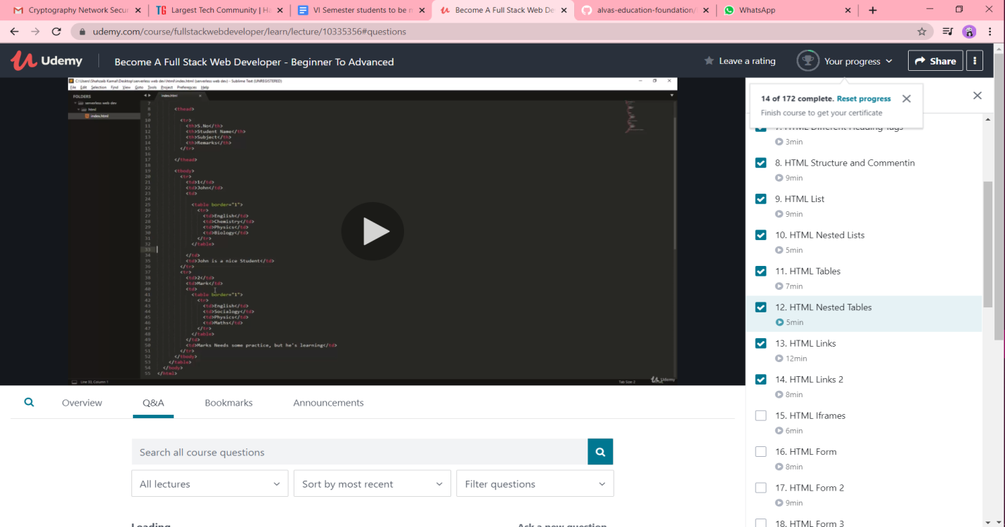

Coding challenge output

1]

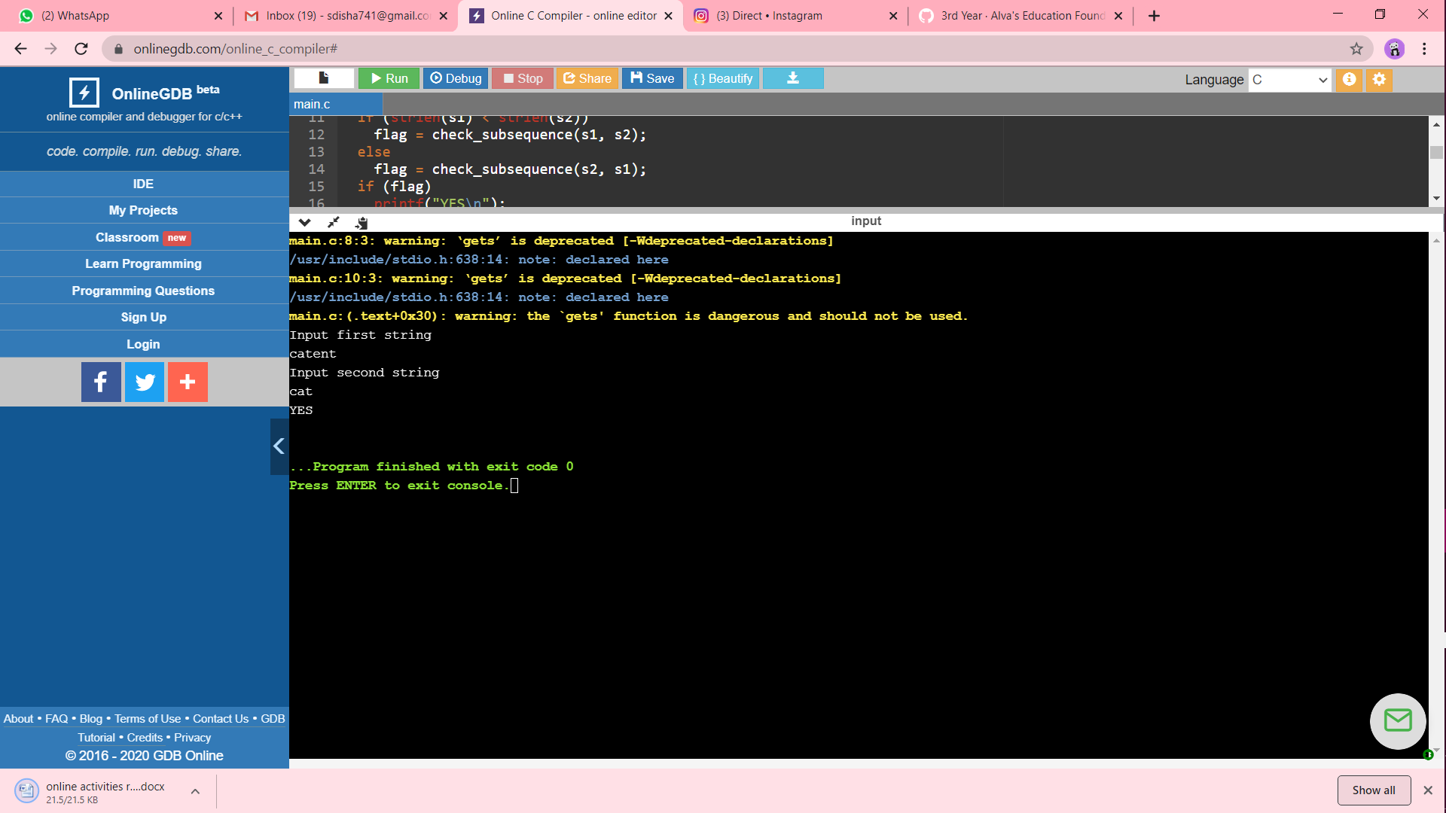

2]

